A deeper look into the PCB

12V input side of the PCB:
- Power supply and regulation area of the board?
- capacitors, 2r2/4r7/standard resistors, solder bridges, mosfet(?), 6 pin chips
- Likely hardware components to divide down voltage to specific voltages to be supplied to the various components on the board.

TP8485E Full failsafe RS485 Transceriver
- located right behind the RS485 port
- form of serial communication and can support up to 32 devices
- ensures reliability of signal received (reduces effects of noise, interference, signal degradation)
- uses differential driver & receiver
- transmitter creates a differential pair, whereby the receiver will look at the difference btw signals received. Can reconstruct the signal back into a single-ended signal to be interpreted by host.
- differential receiver subtracts signals from each other to reconstruct the signal

HST-0041SAR 10/100 Base-TX Transformer
- located behind the LAN port.
- looking at PCB, can see connections being made btw the LAN port and this peripheral
- https://networkengineering.stackexchange.com/questions/29927/what-is-the-purpose-of-an-ethernet-magnetic-transformer-and-how-are-they-used: gives an overview of what the transformer does
- “The primary purpose is isolation. Typically they are also used as part of the signal conditioning, turning a pair of single-ended drives into a differential signal on transmit and establishing the correct common mode voltage for the receiver on receive.”\
- Appears to be connected to the PHYceiver(?) stated below

NTC5CC256M16ER-EK
- Double Data Rate (DDR) 3, 4GB SDRAM
- 933Mhz
- A high amount of wires appears to be connected to the main processor?
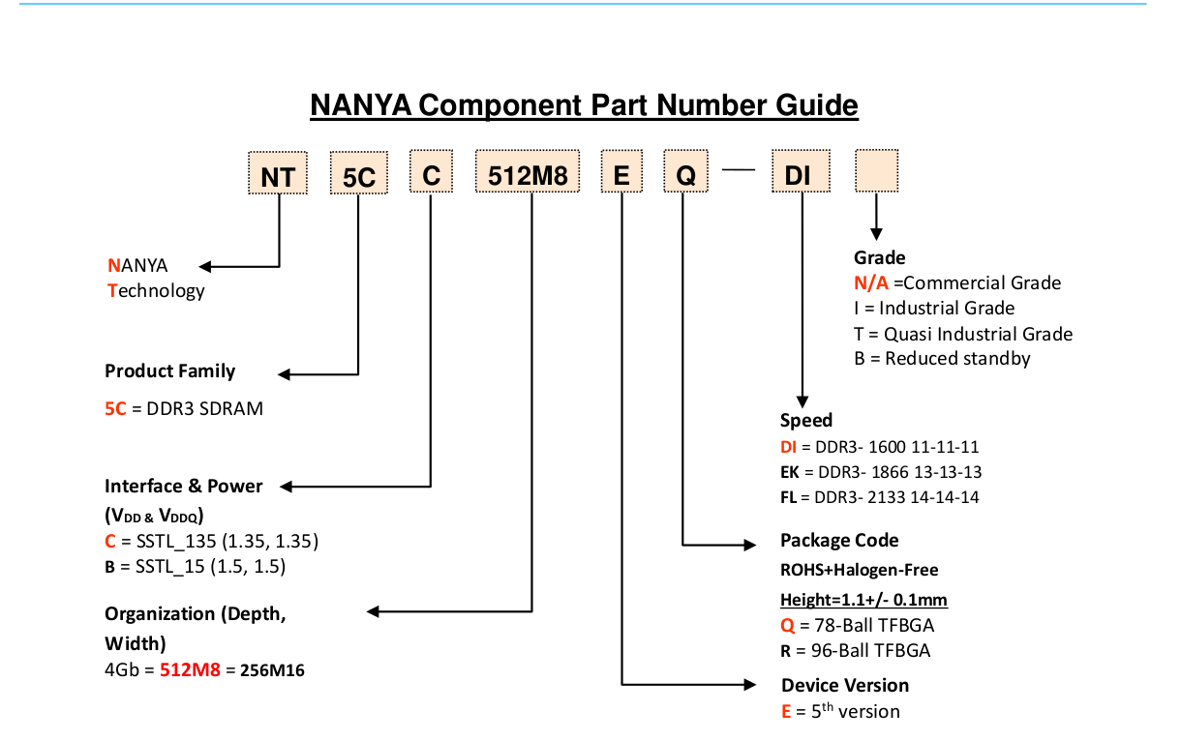

RTL8201F (Ethernet PHYceiver)
- “A PHY connects a link layer device (often called MAC as an acronym for medium access control) to a physical medium such as an optical fiber or copper cable. A PHY device typically includes both physical coding sublayer (PCS) and physical medium dependent (PMD) layer functionality.[16] “
- Follows the OSI model
- Converts bits into physical signals to be sent

Video inputs
- Appears to be connected to Transient Voltage Supressors

2 main processors(?) with heatsinks attached to them (1 big 1 small)
- Good amount of connections btw them
- Small processor is connected to:
- 4 Video Inputs
- Connection btw big and small processors
- Bigger processor appears to be connected to:
- DDR3 Memory
- HDMI input
- Ethernet PHYceiver (RTL8201F)
- UART port? (for flashing firmware)
- one unnamed port that looks like HDMI? Likely for HDD
- Some orange component
- Connected to video output
- Connected to the front touch panel
- Small processor

There is a 32pin slot on the PCB that is empty.
- Appears to be connected to the second UART on the PCB

Questions up until this point:
What is the standard procedure when doing PCB analysis and is there anything in particular that one looks during the process?

Found a useful video: https://www.youtube.com/watch?v=yowJ8TewJoc
It details how to do a firmware update on a separate Hikvision DVR
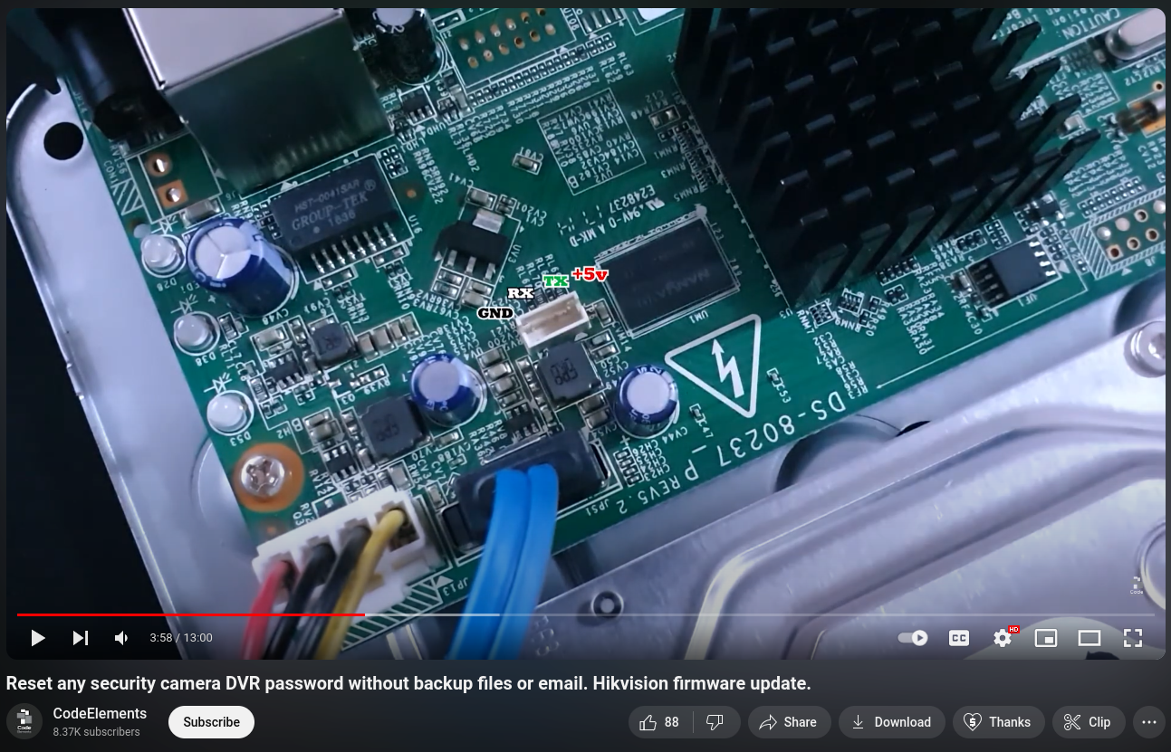
UART Pins

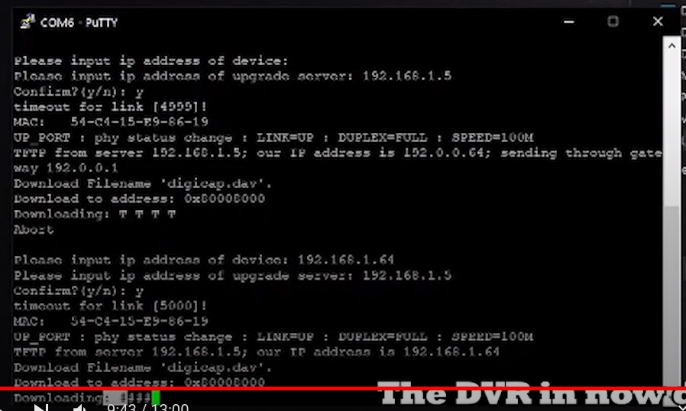
Firmware address location

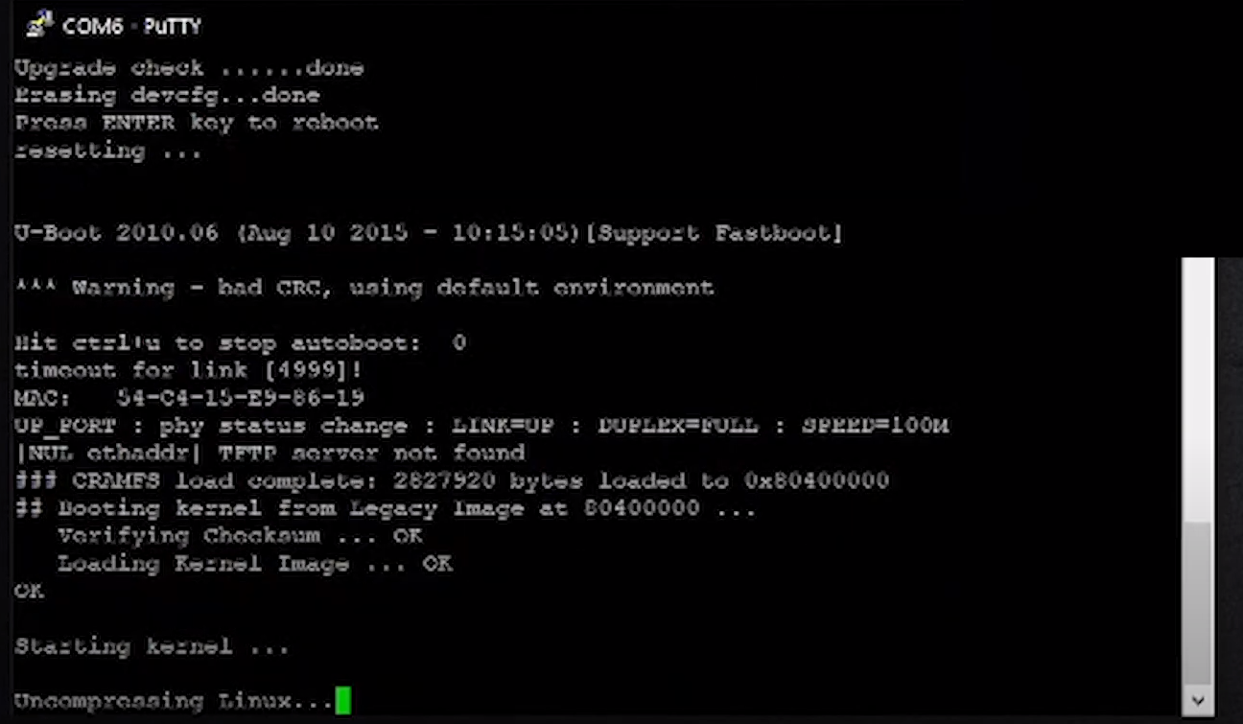
Legacy image present

Due to the heatsink being attached to the processor, I am unable to determine the specific SoC used on the board itself.
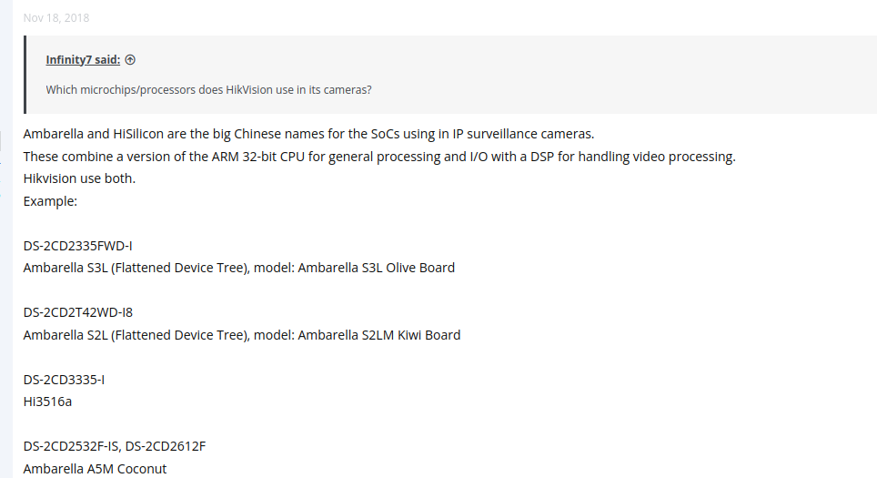
Looking at forums gives me a hint on what chips could have been used and their architecture.

I did try to search for the chip being used, using: the amount of pins and specifications of the hikvision device, trying to match them to existsing chips from the above manufacturers, but to no avail.

I would also like to ask if its possible to remove the heatsink from the chip and if there is a proper way to so.

Moving on, I tried to analyze the .bin file in Ghidra. Currently, the architecture I selected was ARMv7, little endian. I did try out RISC, ARM-Cortex M, and x86 architecture but they all did not give any useful results. With ARMv7, I was able to find a few things.

^ Strings present

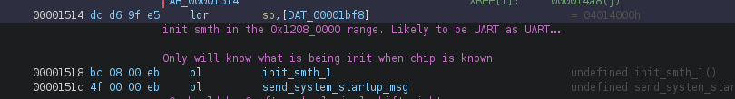
^ Strings are being sent via UART, corresponding to the output seen when the device powers on

Additionally, I looked into the bootup sequence of the ARMv7 architecture: https://www.embeddedrelated.com/showarticle/124.php

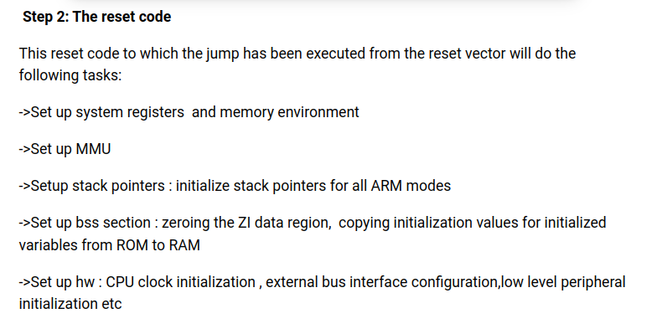
Of particular interest would be this section, whereby it states that it initializes and sets up various peripherals.

When looking at the disassembly, most of the code appears to be initializing certain variables and registers in memory.
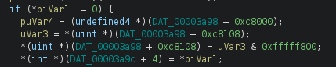

Most follow the format of address + offset, and writing a value to it, similar to how the STM32 does its initialization.
Lastly, at the end of the reset handler, I expected a jump to the main program but it was not the case. Instead, there was a jump back to the reset handler.
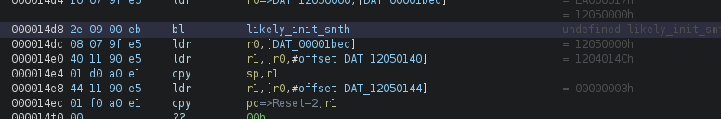

Beyond that, I am unable to make any deeper analysis due to not knowing the specific chips in use.

